Fabric End-to-End Pipeline For ETL Implementation:

SSIS Equivalent Fabric pipeline activities:
- If Condition = Conditional Split in SSIS
- Script Activity = Execute SQL Task/OLE DB Command (runs any DML/DDL on our Database directly)
- Lookup Activity = Lookup Transformation (SELECT only, read-only – cannot run UPDATE statements like Script Activity)
- Copy Data = OLE DB Source + OLE DB Destination
- Dataflow Gen2 = Derived Column + Data Conversion in SSIS (can perform any Power Query transformations)
- Pipeline Variables/Parameters = SSIS Variables/Parameters

2. PolicyDetailInfo – Historical & Incremental Load Pipeline from Source to Stage DB (SSIS Pattern on Fabric)

2.1 Parameter & Variable Configuration (SSIS-like Framework)
Parameters Created:
- HistoricalOrIncrementalLoad
- StartDateTime
- EndDateTime
Variables Created:
- CurrentBatchId
- StartDateTime
- EndDateTime
- LastBatchLoadDateTime

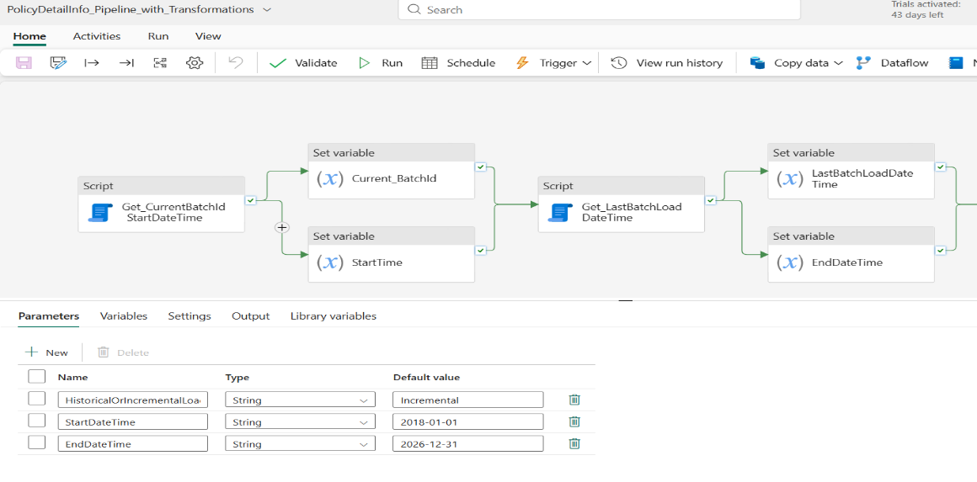
Implementation Method: Used SetVariable Activity for dynamic variable assignment done using existing StoredProcedures.
--SQL Script for Script activity(Get_CurrentBatchId_StartDateTime)
DECLARE @BatchId INT, @StartTime VARCHAR(50)
EXEC [dbo].[usp_InsertBatchInfo_Dummy2]
@HistoricalOrIncrementalLoad = @HistoricalOrIncrementalLoad,
@StartDateTime = @StartDateTime,
@BatchId = @BatchId OUTPUT,
@StartTime = @StartTime OUTPUT
SELECT @BatchId AS BatchId, @StartTime AS StartTime
--Note: Comment/Remove output variables returning statement inside our actual SP
--Set Pipeline Variables(CurrentBatchId,StartDateTime) in further flow from these outputs
--(Set Variables ->CurrentBatchId,StartDateTime) as below using Set Variable activity
@activity('Get_CurrentBatchId_StartDateTime').output.resultSets[0].rows[0].BatchId
@activity('Get_CurrentBatchId_StartDateTime').output.resultSets[0].rows[0].StartTime

--SQL Script for Script activity(Get_LastBatchLoadDateTime)
DECLARE @StartDateTime DateTime2, @EndDateTime DateTime2
DECLARE @LoadType VARCHAR(100) = '@{pipeline().parameters.HistoricalOrIncrementalLoad}'
DECLARE @HistoricalStartDateTime VARCHAR(200) = '@{pipeline().parameters.StartDateTime}'
DECLARE @HistoricalEndDateTime VARCHAR(200) = '@{pipeline().parameters.EndDateTime}'
DECLARE @CurrentBatchId BIGINT
DECLARE @IncEndDateTime VARCHAR(200)
DECLARE @LastBatchLoadDateTime DateTime2
SET @CurrentBatchId = @{variables('CurrentBatchId')}
SET @IncEndDateTime = '@{variables('StartDateTime')}'
IF(@LoadType = 'Historical')
BEGIN
SET @StartDateTime = CONVERT(datetime2, @HistoricalStartDateTime, 121)
SET @EndDateTime = ISNULL(CONVERT(datetime2, @HistoricalEndDateTime, 121), DATEADD(day, -1, GETDATE()))
SELECT
FORMAT(@StartDateTime, 'yyyy-MM-dd HH:mm:ss.fff') AS LastBatchLoadDateTime,
FORMAT(@EndDateTime, 'yyyy-MM-dd HH:mm:ss.fff') AS EndDateTime
END
ELSE
BEGIN
EXEC [dbo].[usp_GetLastBatchLoadDateTime_Dummy2]
@BatchId = @CurrentBatchId,
@IncEndDateTime = @IncEndDateTime,
@HistoricalStartDateTime = @HistoricalStartDateTime,
@HistoricalEndDateTime = @HistoricalEndDateTime,
@LastBatchLoadDateTime = @LastBatchLoadDateTime OUTPUT,
@EndDateTime = @EndDateTime OUTPUT

SELECT FORMAT(@LastBatchLoadDateTime, 'yyyy-MM-dd HH:mm:ss.fff') AS LastBatchLoadDateTime,
FORMAT(@EndDateTime, 'yyyy-MM-dd HH:mm:ss.fff') AS EndDateTime
END
--Note: Comment/Remove output variables returning statement inside our actual SP
--Set Pipeline Variables(LastBatchLoadDateTime, EndDateTime) in further flow from these outputs
--(Set Variables ->(LastBatchLoadDateTime, EndDateTime using Set Variable activity
@{activity('Get_LastBatchLoadDateTime').output.resultSets[0].rows[0].LastBatchLoadDateTime}
@activity('Get_LastBatchLoadDateTime').output.resultSets[0].rows[0].EndDateTime

2.2 Loading ID Tables (Before loading Main table- PolicyDetailInfo)
ID Tables Processed:
- Policy.Policy
- Policy.PolicyDetail
- Policy.Transaction
Load Logic :
- Historical Load(True condition inside If Condition activity): Full table copy from Source DB to Stage DB if Stage table has zero records using CopyData activity.
- Incremental Load(False condition inside If condition activity): Fetch MaxID from Stage, insert only records with ID > MaxID from Source to stage using CopyData activity.

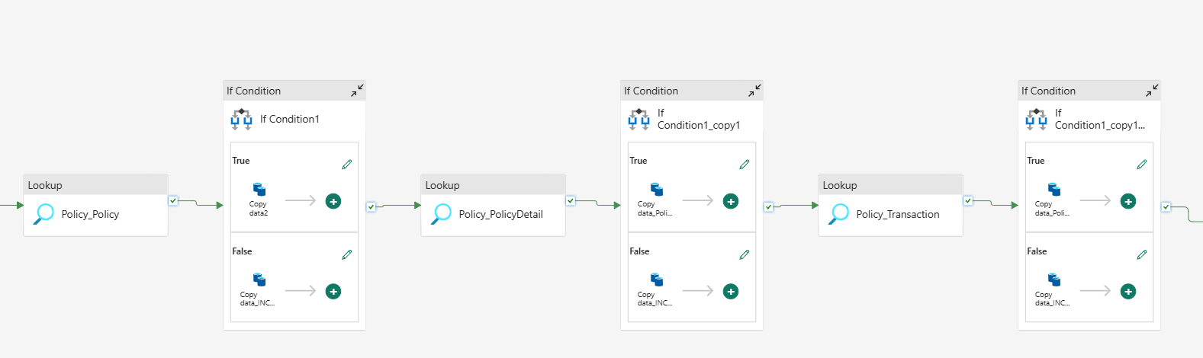

--Lookup activity scripts: fetching RecordCount,MaxId from Stage Tables
--Policy_Policy
select Count(*) as TableCount,Max(PolicyId) as MaxID from Policy.Policy_Dummy

--Policy_PolicyDetail
select Count(*) as TableCount,Max(PolicyDetailId) as MaxID from Policy.PolicyDetail_Dummy

--Policy_PolicyTransaction
select Count(*) as TableCount,Max(TransactionId) as MaxID from Policy.Transaction_Dummy

--If condition activity Expression (same script for all ID tables with different activity_names)
@equals(activity('Policy_Policy').output.firstRow.TableCount,0)
--if TableCount=0 for stage flow navigates to True block otherwise False block

--CopyData activity for Hist (True path)->directly we select tables in source(Source DB table) and destination(Stage DB table)

--CopyData activity for INC load(False path) we have source query on Source DB as below and select table on destination(stage Db table)- same for all ID tables having different activity names.
select * from Policy.Policy where PolicyId>@{activity('Policy_Policy').output.firstRow.MaxID}

2.3 Loading Main table PolicyDetailInfo:
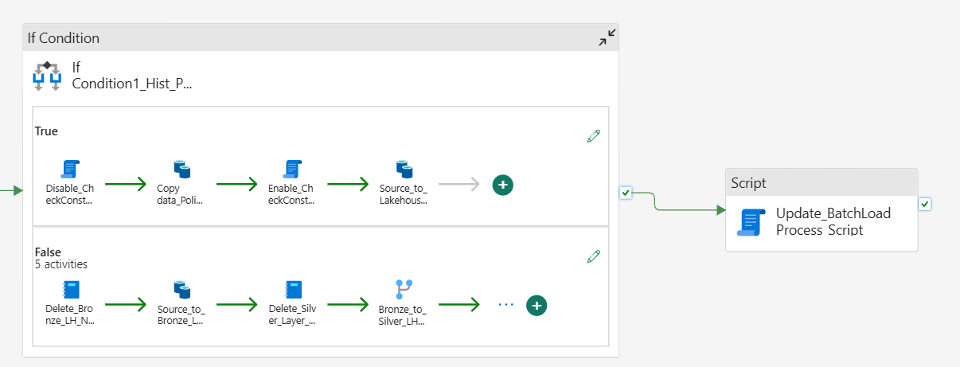

2. 3.1 If Condition Activity – Historical vs Incremental Decision
If Condition Activity : checks if HistoricalOrIncremental parameter value equals to ‘Historical’
- True Condition: Historical Load – Full table copy from Source DB to Stage DB
- False Condition: Incremental Load – Delta records based on ModifiedDateTime from Source to Bronze Lakehouse → Transformed → Stage DB
--If condition activity Expression
@equals(pipeline().parameters.HistoricalOrIncrementalLoad, 'Historical')

2.3.2 Historical Load Path (Full Load):
Step 1: Script Activity disables check constraints on Stage DB to avoid FK violations during bulk insert.
--Script Activity disables script
ALTER TABLE [Policy].[PolicyDetailInfo_Dummy2]
NOCHECK CONSTRAINT [FK_PolicyDetailInfo_Policy_Dummy2];
ALTER TABLE [Policy].[PolicyDetailInfo_Dummy2]
NOCHECK CONSTRAINT [FK_PolicyDetailInfo_PolicyDetail_Dummy2];
ALTER TABLE [Policy].[PolicyDetailInfo_Dummy2]
NOCHECK CONSTRAINT [FK_PolicyDetailInfo_Transaction_Dummy2];
ALTER TABLE [Policy].[PolicyDetailInfo_Dummy2]
NOCHECK CONSTRAINT [FK_PolicyDetailInfo_Transaction1_Dummy2];

Step 2: CopyData Activity inserts all records from Source DB table into PolicyDetailInfo table in Stage DB, with an additional derived BatchId column from pipeline variable.
--CopyData activity source query (which is connected to PolicyAdmin10-Dev)
@concat(
'Select *
,CAST(''', string(variables('CurrentBatchId')), ''' AS BIGINT) AS BatchId
from Policy.PolicyDetailInfo')
-- CopyData activity Destination side(we select Stage table directly)

Step 3: Script Activity re-enables all previously disabled check constraints on Stage DB.
----Script Activity enables script
ALTER TABLE [Policy].[PolicyDetailInfo_Dummy2]
CHECK CONSTRAINT [FK_PolicyDetailInfo_Policy_Dummy2];
ALTER TABLE [Policy].[PolicyDetailInfo_Dummy2]
CHECK CONSTRAINT [FK_PolicyDetailInfo_PolicyDetail_Dummy2];
ALTER TABLE [Policy].[PolicyDetailInfo_Dummy2]
CHECK CONSTRAINT [FK_PolicyDetailInfo_Transaction_Dummy2];
ALTER TABLE [Policy].[PolicyDetailInfo_Dummy2]
CHECK CONSTRAINT [FK_PolicyDetailInfo_Transaction1_Dummy2];

Step 4: CopyData Activity loads Source DB table data into Bronze-layer Lakehouse PolicyDetailInfo table for future incremental load reference.
Note: It took 4mins 3secs to complete Historical load (Proccessed around 31,000 records of PolicyDetailInfo table from source to stage)
Incremental Load Path(without Transformations):
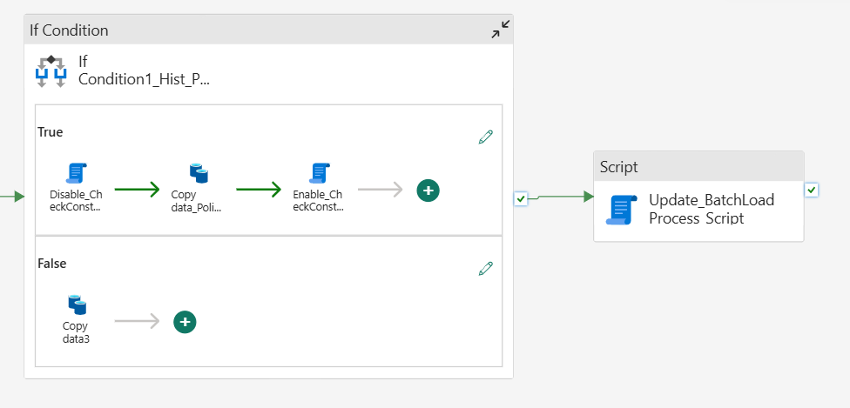
This activity implemented in another DataPipeline separately without applying Transformations.(This INC flow is doing inserts and updates correctly from source to stage).
It Simply consists of a single Copy Data activity that fetches only the latest records from the Source DB based on ModifiedDateTime, adds an additional BatchId column (derived from the CurrentBatchId pipeline variable), and performs an upsert into the Stage DB using key columns (PolicyId, PolicyDetailId, InTransactionId).
Note: It took 3mins 15secs to complete Incremental load (to process 139 modified records)
Update Trigger Implementation for Tracking Modified Records:
Created an UPDATE trigger in the Stage-Old DB to set the UpdatedTimeStamp column to the current datetime for records updated during the pipeline’s Copy Data upsert operation.
SET ANSI_NULLS ON
GO
SET QUOTED_IDENTIFIER ON
GO
Alter TRIGGER [Policy].[trg_PolicyDetailInfo_Dummy2_UpdatedTimestamp]
ON [Policy].[PolicyDetailInfo_Dummy2]
AFTER UPDATE
AS
BEGIN
SET NOCOUNT ON;

UPDATE [Policy].[PolicyDetailInfo_Dummy2]
SET [UpdatedTimeStamp] = GETDATE()
FROM [Policy].[PolicyDetailInfo_Dummy2] pdi
INNER JOIN inserted i
ON pdi.PolicyDetailInfoId = i.PolicyDetailInfoId
END

Note: The update trigger works as expected; however, in the Incremental Load Path (with transformations), it incorrectly updates the UpdatedTimeStamp for all previous batch records because the dataflow is not consistently refreshed through the pipeline (as mentioned in Step 4 under the below Incremental Load Path section).

2.3.3 Incremental Load Path (With Transformations):
Step 1: Notebook Activity called from this pipeline-> truncates the Bronze_Layer Lakehouse PolicyDetailInfo table to remove previous data.
--Truncate statement in notebook cell
%%sql
TRUNCATE TABLE Policy.PolicyDetailInfo

Step 2: CopyData Activity fetches only incremental records from Source DB based on ModifiedDateTime filter and inserts them into Bronze Lakehouse PolicyDetailInfo table.
--Source query (connected to PolicyAdmin10-Dev SourceDB)
@concat(
'Select *
from Policy.PolicyDetailInfo
WHERE ModifiedDateTime IS NOT NULL
and ModifiedDateTime >= Cast(''', variables('LastBatchLoadDateTime'), ''' as Datetime2(7))
and ModifiedDateTime < Cast(''', variables('EndDateTime'), ''' as Datetime2(7))'
)
--In Destination tab(select Lakehouse_Bronze-> Policy.PolicyDetailInfo table and choose option Append (as we are truncating table previously in flow using notebook).

Step 3: another Notebook Activity called from this pipeline will truncates the Silver_Layer Lakehouse PolicyDetailInfo table to prepare for fresh transformed data.
--Truncate statement in notebook cell
%%sql
TRUNCATE TABLE dbo.Policy_PolicyDetailInfo

Step 4: Dataflow Gen2 transforms data from Bronze Lakehouse(source) to Silver Lakehouse(destination) by adding a derived BatchId column (injected dynamically via pipeline variable reference->parameter passing) and converting data types from Date to DateTime for required columns.
However, the dataflow is not consistently refreshing through the pipeline, which causes previous batch records to remain in the Dataflow UI. As a result, it fails to fetch the latest data from the Lakehouse_Bronze layer and instead inserts outdated records into the Lakehouse_Silver layer, leading to unnecessary updates in the stage table(But pipeline flow succeeds without any failure, so we can’t see refreshing Dataflow failed in pipeline).

--PowerQuery M code for Policy_PolicyDetailInfo table in Dataflow
let
Source = Lakehouse.Contents(null),
Navigation = Source{[workspaceId = "088cfb93-b769-4153-90f0-19bbebe487cc"]}[Data],
#"Navigation 1" = Navigation{[lakehouseId = "2385716e-78ed-4969-9b97-709df3bd309b"]}[Data],
#"Navigation 2" = #"Navigation 1"{[Id = "Policy.PolicyDetailInfo", ItemKind = "Table"]}[Data],
Add_BatchId = Table.AddColumn(#"Navigation 2", "BatchId", each Parameter_BatchId),
#"Changed column type" = Table.TransformColumnTypes(Add_BatchId, {
{"EffectiveDate", type datetime}, {"ExpirationDate", type datetime},{"PolicyInceptionDate", type datetime}, {"TermEffectiveDate", type datetime}, {"TermExpirationDate", type datetime},
{"BatchId", Int64.Type}
})
in
#"Changed column type"

Note: create a Parameter(BatchId) inside Dataflow with some default value=0

Step 5: CopyData Activity loads the transformed data from Silver Lakehouse PolicyDetailInfo table into the final destination Stage DB table.
Note: This INC load took 6mins 24secs to complete (to process 139 modified records)

2.3.4 Data Type Conversion Strategy
Step 1: Source DB columns (PolicyInceptionDate, TermEffectiveDate, TermExpirationDate, EffectiveDate, ExpirationDate) with Date datatype are extracted from Source DB.
Step 2: Data is first loaded into Bronze-Layer Lakehouse as-is without any conversion.
Step 3: Dataflow Gen2 performs the conversion from Date to DateTime(timestamp datatype) for all five date columns and Derives new column(BatchId) during Bronze → Silver transformation.
Step 4: Converted data is loaded into Silver-Layer Lakehouse with DateTime(timestamp datatype) datatype.
Step 5: Final CopyData Activity loads the transformed data from Silver Lakehouse to Stage DB table where target columns expect DateTime2(7).
Pipeline Flow: Source DB (Date) → Bronze Lakehouse (Date) → Dataflow Gen2 (Conversion) → Silver Lakehouse (DateTime2(7)) → Stage DB (DateTime2(7))

2.3.5 Batch Process Auditing
- Activity: Script Activity (last activity in flow - named as Update_BatchLoadProcess_Script in pic)
- Operation: Update Batch.Batchloadprocess table
- Action: Set status to Completed, and completion Time calculated using existing stored procedure
--Script Activity’s script
DECLARE @StartDateTime DATETIME = CONVERT(DATETIME, '@{variables('StartDateTime')}', 121)
DECLARE @CurrentBatchId BIGINT = @{variables('CurrentBatchId')}
DECLARE @EndDateTime DATETIME = @EndDateTime_New

EXEC usp_UpdateBatchInfo_Dummy2 @StartDateTime, @CurrentBatchId, @EndDateTime
--Note: Pass @EndDateTime_New as script parameter defined here with Datetime datatype and with value(GetDate()) as below:
@formatDateTime(utcNow(), 'yyyy-MM-dd HH:mm:ss')

